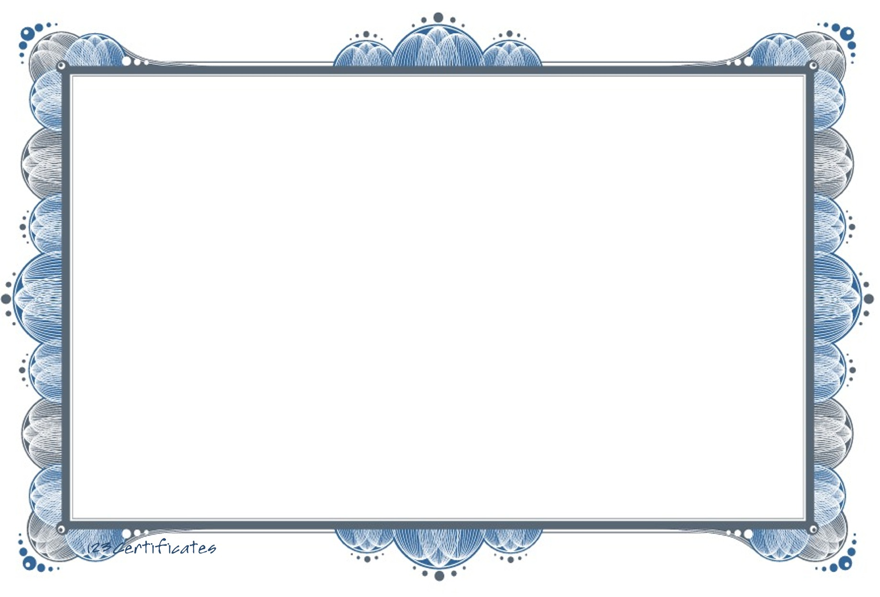

# Certificate of Appreciation

The following award is given to:

## Elmer Gibbs

This certificate is given Elmer Gibbs

For his achievement in the field of education and proves that he is competent in his field

_________________________

Kendra Wagner

### Mentor

_________________________

Andy Pittman

### Head of Event

### Date : 03/01/2023